<TripApp>
<Raptors Inc.>

Table of Contents
1. Introduction 4
1.1 Purpose 4
1.2 Scope 4
1.3 Definitions, Acronyms and Abbreviations 4
1.4 References 5
1.5 Technologies to be used 5
1.6 Overview 5
2. Overall Description 6
2.1 Use-Case Model Survey 6
2.2 WEB Architecture diagram 8
2.3 ER Diagram 9
2.4 Architecture diagram 10
2.5 Data Dictionary 11
2.6 Assumptions and Dependencies 15
3. Specific Requirements 166
3.1 Use-Case Reports 12
3.2 Class Diagram 29
3.2 Supplementary Requirements 31

1. Introduction

Purpose
To develop the back end for a fully functional and user interactive online tool which can enhance and help case managers, transportation manager, and drivers to manage and complete their work efficiently and productively

Scope
- Create three types of users: case managers, transportation manager, and drivers.
- Confirm each member by… .
- Manage transportation requests documents by allowing case managers to create and submit them to transportation manager who oversees assigning them to the drivers.
- Assign different tasks to different members.
- Provide documentation to the members about the tasks being added.
- Update all members about changes in the transportation request.
- Bind the information corresponding to each different user and allow to see only the request they need to interact with

Definitions, Acronyms and Abbreviation

OPM – Online Project Management.
Transportation Manager – TM.
CS – Case Manager.
HTML – Hyper Text Markup Language.
XHTML – extensible Hypertext Markup Language.
HTTP – Hypertext Transfer Protocol.
EJB - Enterprise Java Beans.

References

IEEE SRS Format.

TGMC-2008 Sample Synopsis Format.
Problem Definition Provided By TGMC-2008

Technologies to be used

Application Architecture - MVC

Database Application - NoSQL MongoDB -> Mongoose

Development tool - Rational System Developer

Web Deployment Server - Oroku

Designing tool - Rational

Environment - NodeJS -> ExpressJS

Overview
This project is a tool to help in managing transportation operations. It is more useful in cases where communication is key between departments. In this case making available transportation information and the creation of that information to the party whose job depends on that information.

Overall Description

Use-Case Model Survey
Approve and assign Transport Request
To Drivers
Reject TP
Administrator
View All Details
Case Manager
Modify
TR
Send TP to Admin
Create Transportation Request
Drivers
Update TP Status
View TP
Delete
TP

- Transportation Coordinator: - is responsible for assigning the trips to the drivers.

  - Assign Transport Request: - TC logs into the App and assign trips to Drivers.

- Case Manger - is responsible for creating the transport requests.

  - Create Transport Request: - CM after logging in into his profile creates transportation request.
  - Edit Transport Request: - CM can update the TR. After a trip is updated its status is set to pending.
  - Delete Transport Request: - CM will be able to delete Transport Request.

- Driver: -

  - View Transport Request – The driver will be able to watch the transport request assigned by the TC.

Web Architecture Diagram

HTML CLIENT
(Customer)
HTTP/HTTPS

DB SERVER
WAS

Client Software
(System Users)
TCP/IP

Client Side Application Side DB Server Side
It uses three tier architecture dig where client side application side and DB server are three diff components that improve security in system.

ER Diagram
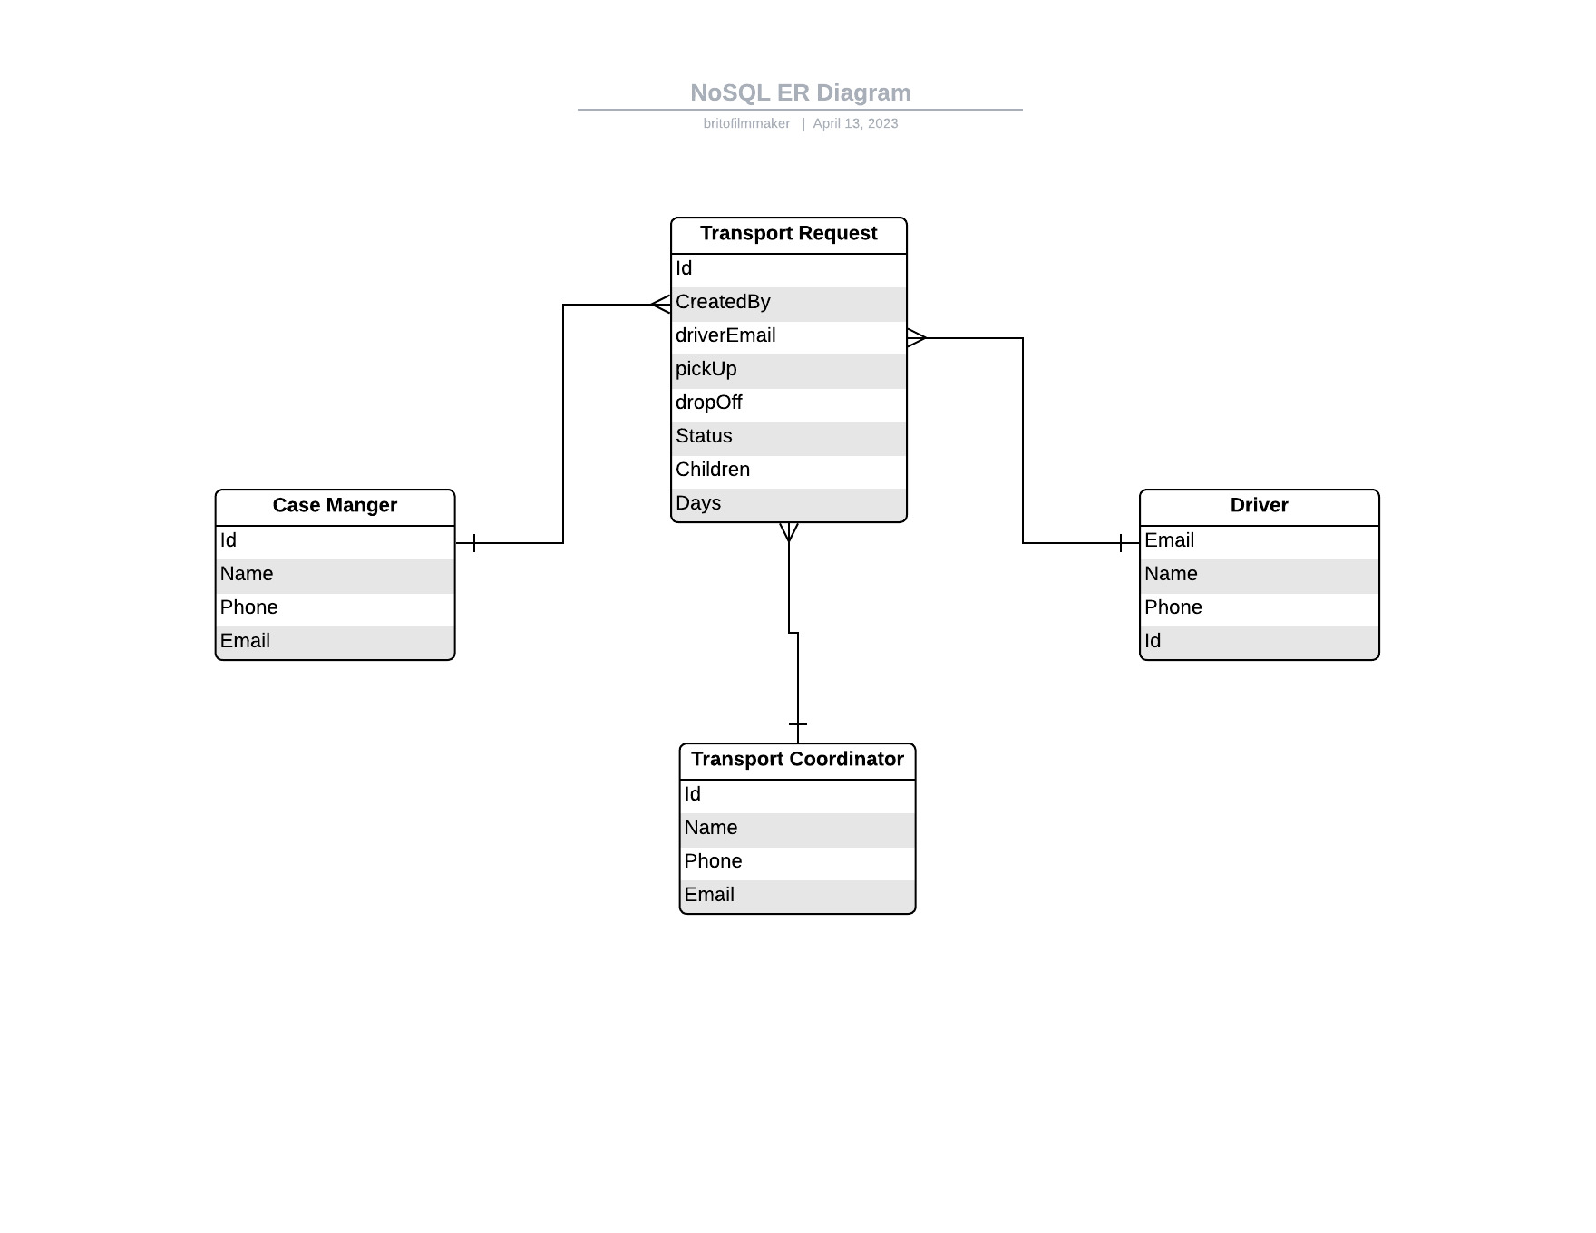

Architecture Diagram

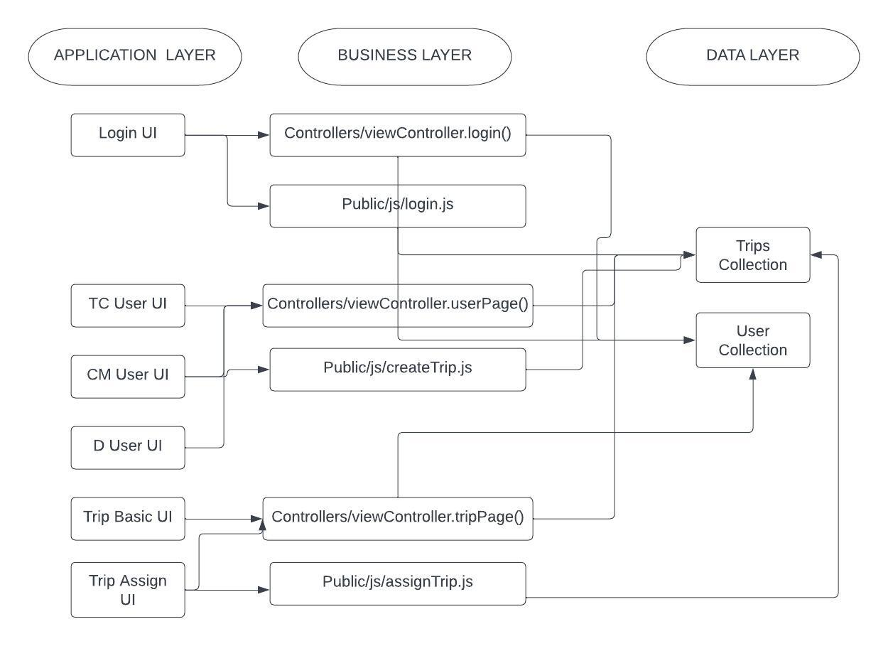

Data Dictionary

All collections used in the Application:

Trips Collection
driverEmail
children
days
pickUp
dropOff
numOfChildren
status
createdBy

Users Collection
name
photo
email
phone
password
passwordConfirm
passwordChangedAt
role
passwordResetToken
passwordResetExpires
active
trips

Assumptions and Dependencies

- The Project Manager from same company is not being assigned to two projects.

- Administrator can also be a project manager for a project.

Specific Requirements

Use-Case Reports

- Case Manger- is responsible for creating, updating, and delete trips.

  - Create a Trip- The Case Manager creates a trip that would them be visible to the Transportation Coordinator. When the trip is initially created, its status is set to pending.
  - Update a Trip- The Case Manger updates the information of a trip. This then set the trip status to pending.
  - Delete a Trip- The Case Manger is able to delete trips, when transportation is no longer need or the trip is rejected by the Transport Coordinator.

Name of Use Case – Create a New Trip.

Description – a new trip will be created in the database.

Pre Condition –The Case Manager should be logged in to the system.

Normal Flow of Events –

- A form will be open once the Case Manager logs in, necessary information will be entered.

- The create() method is called on the trip model with the information entered in the form.

- The save() method is called on this trip object returned by the model.

- The trip object is send wrapped in a JSON object in the HTTP response to the client.

USE CASE DIAGRAM
New trip Details Filled In
Trip Saved into Data Base
HTTP Response Sent to Client
HTTP Req Sent to Server

Work Flow Diagram

Trip Saved in Data Base
New trip Details Filled In

HTTP Request Sent to Server

HTTP Response Sent to Client

Name of Use Case – Update Trip.

Description – a Trip information will be changed and it status property will be set to pending.

Pre Condition The Case Manager should be logged in to the system.

Normal Flow of Events –

- The tripUpdate.pug page will be opened once the Case Manger clicks on the update button of the trip

- A form will be present where the Case Manager will submit the information to be updated.

- Once the form is submitted the trip will be update and its status will be set to pending.

- The trip will appear in the Transportation Coordinator page.

USE CASE DIAGRAM
Transport Coordinator
New Details Filled In
Trip Update in Data Base

WORK FLOW DIAGRAM

New Details Filled In
Trip Update in Data Base

2. Driver – is responsible for managing the overall project, it’s tasks, messages, reports, related deadlines and documents

- View List of Trips Assigned to Driver – The driver will be able to view a list of all the trips assigned to the driver by the transport coordinator.
- View Trip in Detail – The driver will be able to view page with more details of each trip in the list.

Name of Use Case – View Trips Assigned to the Driver

Description – The database will be query. A list of the trips assigned to the Driver will be displayed.

Pre Condition –

- The Driver should be logged in the system.

Normal Flow of Events –

- The database will queried, and a list of the driver’s trip will be displayed.

USE CASE DIAGRAM
Database queried.
List of trips displayed.
DB – Trips Collection
WORK FLOW DIAGRAM
Database queried

List of trip displayed

Name of Use Case – Create New Task

Description – PM starts new task and assign team members to it.

Pre Condition –

- The PM should be logged in the system.

Normal Flow of Events –

- A task will be added to the project and timelines will be displayed.

- Team Members will update the task status.

- The Project completion status will also be updated.

USE CASE DIAGRAM
A Task will be added to project
Team Member Update task status
Project Completion status updated
Team Member

WORK FLOW DIAGRAM
Task Is Added to the Project
Team Member updates task status
Project Completion status updated

Name of Use Case – Create New Message.

Description – a new message will be created which will be displayed to all the users.

Pre Condition –

- The PM should be logged in the system.

Normal Flow of Events –

- A Msg will be created by filling in details of the msg.

- This msg will be displayed to all the active users of the project.

USE CASE DIAGRAM

A MSG will be created
Displaying MSG to active user
Team Member

WORK FLOW DIAGRAM
A MSG will be created

Displaying MSG to active user

Name of Use Case – Provide documentation.

Description – a task or project related document will be given to the team members for their guidance

Pre Condition –

- The PM should be logged in the system.

Normal Flow of Events –

- A document will be uploaded to the system.

- Other team members can read the doc.

USE CASE DIAGRAM

Uploading of DOC to system
Accessibility of DOC to other members
Team Member

WORK FLOW DIAGRAM
Uploading of DOC to system

Accessibility of DOC to other members

Name of Use Case – Generate Reports.

Description – a report can be generated by the PM at any instance of time to view the project completion status

Pre Condition –

- The PM should be logged in the system.

Normal Flow of Events –

- A project report will be generated

- A database entry would be made.

USE CASE DIAGRAM
Generation of project report
Enter information to database

WORK FLOW DIAGRAM
Generation of project report

Enter information to database
Name of Use Case – Update Project Status.

Description – a PM can update the project status by looking at the task completion status.

Pre Condition –

- The PM should be logged in the system.

Normal Flow of Events –

- Analyze project tasks.

- Update project completion status.

USE CASE DIAGRAM
Analyze Project task
Update project completion status

WORK FLOW DIAGRAM

Analyze Project task

Update project completion status

Name of Use Case – decide deadlines.

Description – a time line i.e. a start date and an end date would be set for every task.

Pre Condition –

- The PM should be logged in the system.

Normal Flow of Events –

- Set a start date and an end date.

USE CASE DIAGRAM
Set a start date and an end date

WORK FLOW DIAGRAM
Set an start date and an end date

3. Team Member – is responsible for updating task status and completing the task so that the project may not get delayed.

- Update Task Status – the team member is responsible for updating the completion status of the project.

- Create/ update MSG – the team member can create and update the msgs.

Name of Use Case – update task status.

Description – completion status of the task could be updated.

Pre Condition –

- The Team Member should be logged in the system.

Normal Flow of Events –

- Sets the percentage completion status.

USE CASE DIAGRAM
Set the percentage completion status

WORK FLOW DIAGRAM
Set the percentage completion status

Name of Use Case – create/ update MSG.

Description – a new MSG will be created or an already existing MSG will be updated.

Pre Condition –

- The Team Member should be logged in the system.

Normal Flow of Events –

- Create a new msg

- Edit an already existing msg.

USE CASE DIAGRAM
Create a new MSG
Edit an already existing Msg
WORK FLOW DIAGRAM

Create a new Msg

Edit an already existing MSG

Class Diagram
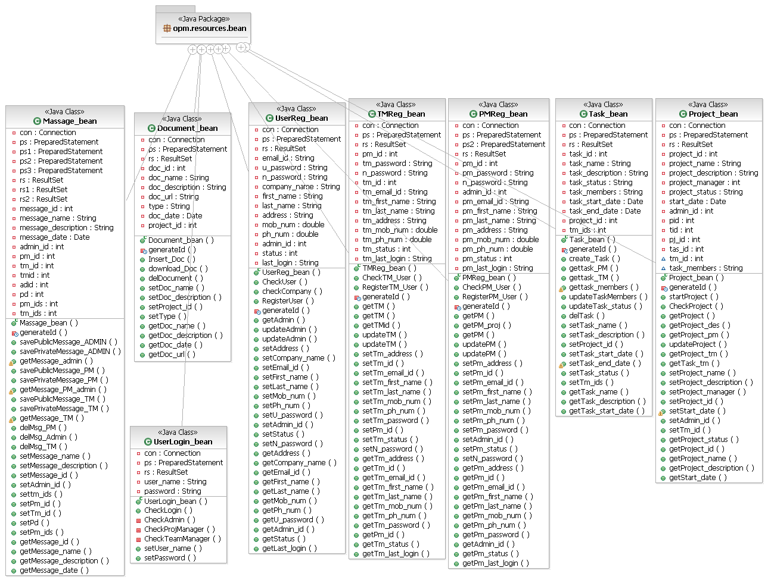

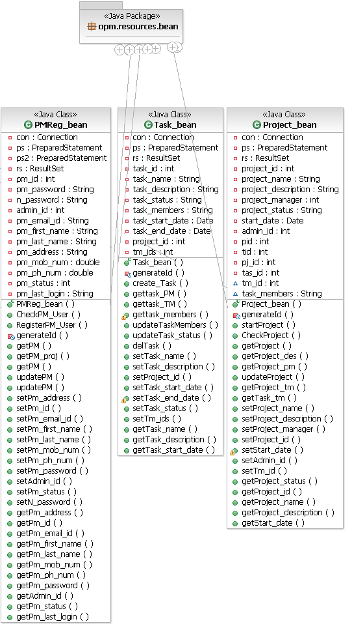

Supplementary Requirements

- Since this a tool which can be used from anywhere and anytime in the world, so the server should be well managed for such kind of requirement.

- The users using this and importing the reports from this tool should have supporting software to run them.

- To use the application in the best possible way please read the tips displayed while using the tool.

